**Microprocessor, Microcontroller and Interface Techniques Lab**

**AND Operation Output**

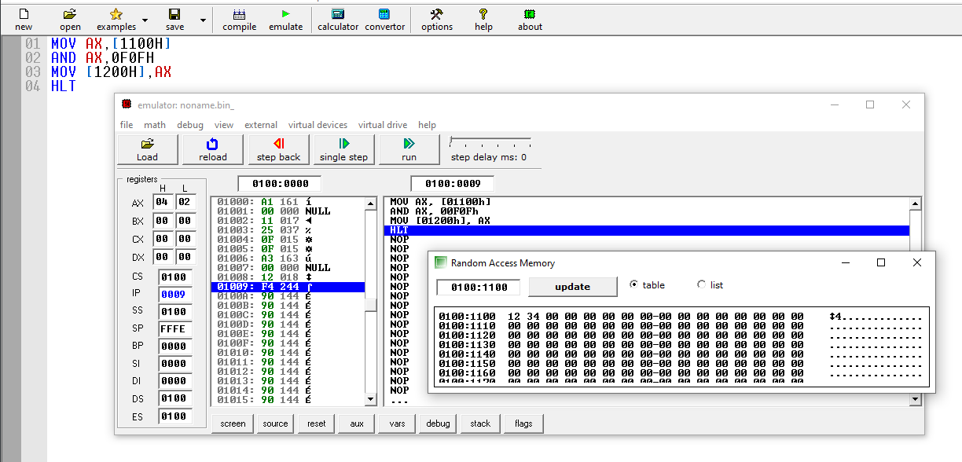

**OR Operation Output**

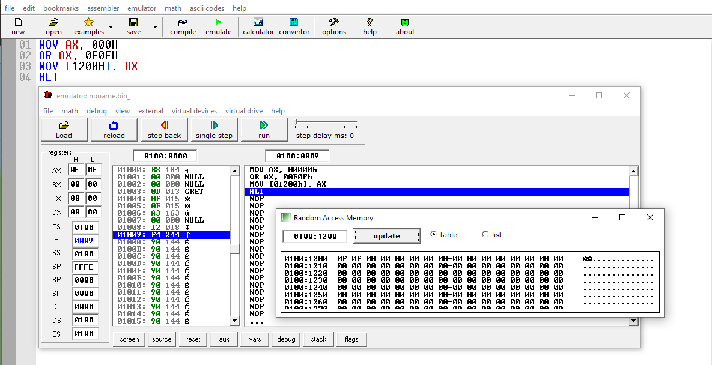

**Post Lab**

**NAND Operation**

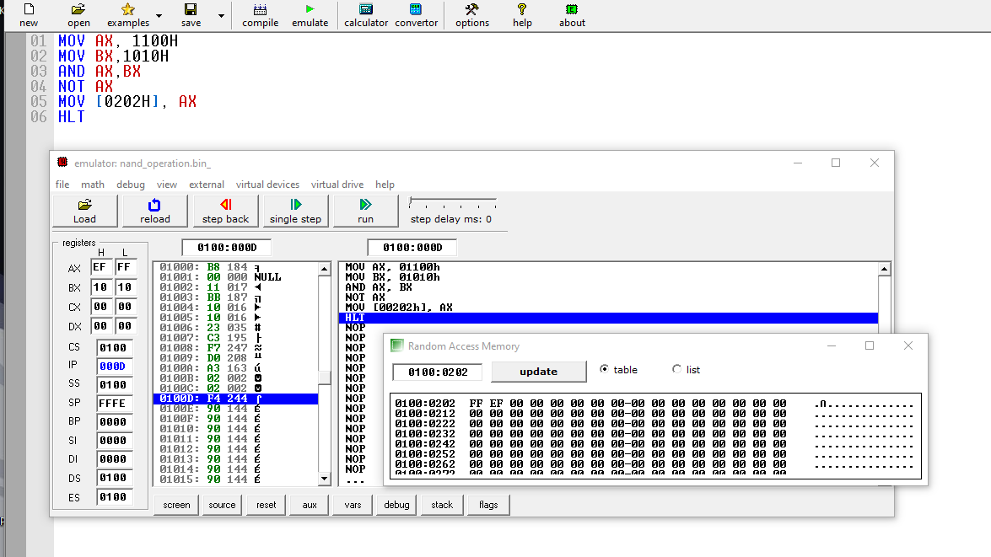

**NOR Operation**

